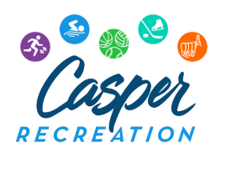

23rd Annual One Pitch Softball Tournament Registration Form

Date: August 13 & 14, 2022
4 Game Guarantee, USA Softball Rules and Umpires, team t-shirts will be awarded to 1st, 2nd place. Take advantage of online registration through www.crlasports.com.
Team Registration Deadline – Thursday, July 31st, 2022
Please register my team for the following:

Men’s Entry fee: $225

______Women’s Entry fee: $225

______Coed Entry fee: $225

Team Name

Division (Circle one): Competitive Recreational

Team Contact Person’s Name:

Email:

Street Address:

City: State: Zip:

Main Phone # Secondary Phone #

Make all checks payable to CRLA and mail to:
CRLA 1801 E 4th St, Casper, WY 82601 or register online @ crlasports.com

